Model for Preparing BIG Mountain’s Pricing and Future investment Strategy

Prepared by Reetu Sharma

Springboard

1. Mar 21

**Abstract**: Big mountain resort has been reviewing the potential scenarios for either cutting costs or increasing revenue from ticket prices. There is not any direct relation of ticket prices with any provided facilities. Business is free to set any price with given information. By this analysis report, it has been tried to reveal whether the current ticket prices are significant with the facilities or not. Second, fact to focus on is increasing revenue either by stopping or reducing some facilities which are less significant in nature. This report also highlights some of the other supporting data which could be better to have for a prediction of the future market conditions.

**Introduction.** A big mountain resort is a ski resort located in Montana. It has upgraded its facilities which has increased the operating costs by $1540,00. There are many features to look on for better business it includes vertical_drop, Total_chairs, Fast_quads, Snow MakingAc, runs, dayOpenLAstYear and most import ticket pricing and operational cost for some provided facilities. In this analysis we are going to compare and look for all possible factors which could/should be changed to increase the revenue of business.

**Data collection-** For this analysis data has been taken from two different sources one the Ski_data, CSV format and second one State_wide summary was collected from online available information.

Missing but valuable supporting Data for future interest:

Number visitors per season/year?

How many competitors are there and what kind of facilities they are proving in same ticket pricing?

Data related to operational, maintenance cost of any facilities which we want to keep, reduce or permanently remove as per the market conditions.

**Data Analysis:** All related data were trained and test by both random forest and linear regression model and assessed the performance of both models through cross-validation and GridsearchCV. After validation, Random Forest model was selected as final model as it showed lower absolute mean error, less variability and consistency for cross validation results for this model. Following are some parameters to consider for final modelling.

vertical_drop

Snow Making_ac

total_chairs

fastQuads

Runs

LongestRun_mi

trams

SkiableTerrain_ac

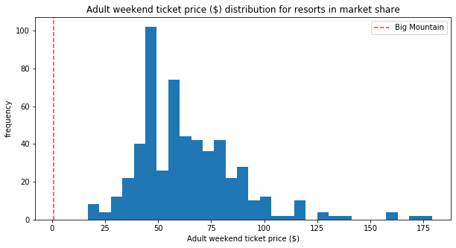 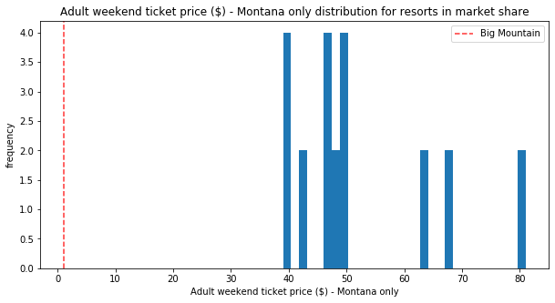

Montana resort shows quit different ranges for ticket pricing.

.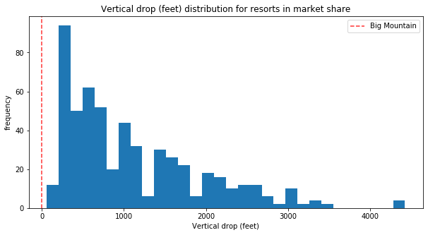

Big Mountain is doing well for vertical drop, with a few resorts with a greater drop.

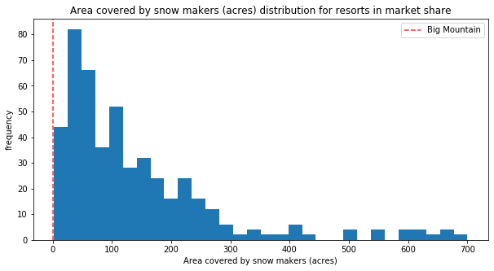.

Big Mountain is very high up the league table of snow making area.

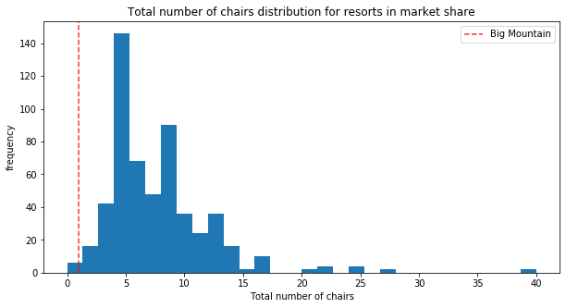

Big Mountain has amongst the highest number of total chairs, resorts with more appear to be outliers.

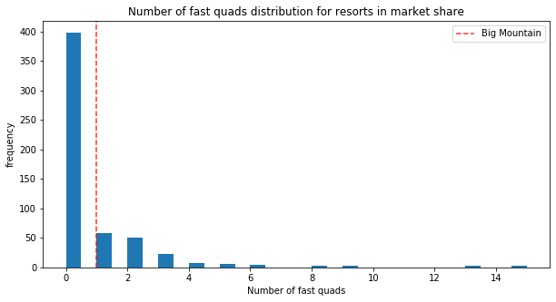

most resorts have no fast quads. Big Mountain has 3, which puts it high up that league table. There are some values much higher, but they are rare.

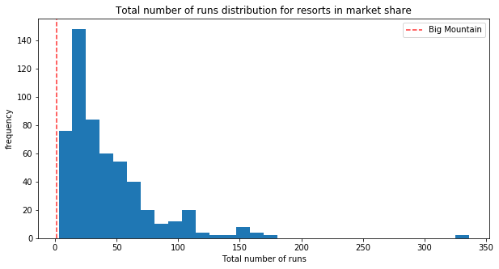

Big Mountain compares well for the number of runs. There are some resorts with more, but not many.

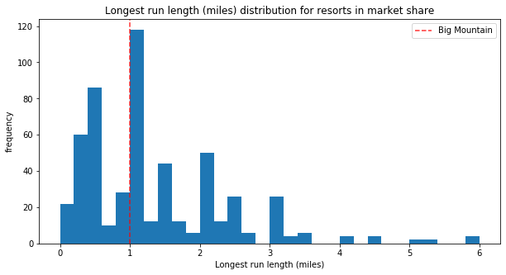

Big Mountain has one of the longest runs. Although it is just over half the length of the longest, the longer ones are rare.

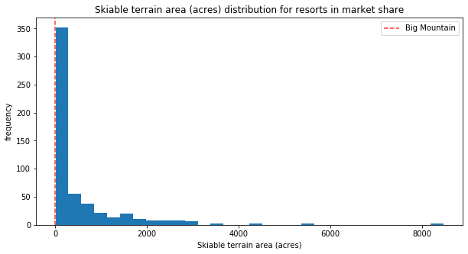

Big Mountain is amongst the resorts with the largest amount of skiable terrain.

Results:

Case 1

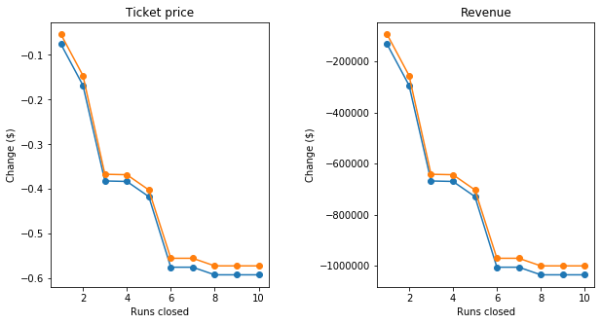

As we can see from the graphs, closing one run makes no difference. Closing 2 and 3 runs successively reduces support for ticket price and so revenue. If Big Mountain closes 3 runs, it seems they may as well close 4 or 5 as there is no further loss in ticket price. It’s not a good idea to close runs 6 or more as it is showing large gap and drops.

CASE 2

Adding a run, increasing the vertical drop by 150 feet, and installing an additional chair lift. This scenario increases support for ticket price by $9.52. Over the season, this could be expected to amount to $16661750

CASE 3

Adding acres of snow making. This increases support for ticket price by $11.48. Over the season, this could be expected to amount to $20086500. Such a small increase in the snow making area makes no difference!

CASE 4 Increasing the longest run by .2 miles and guaranteeing its snow coverage by adding 4 acres of snow making capability. No difference whatsoever.

**CONCLUSION**

**Big Mountain resorts are undercharging as per our analysis. It can be affected from so many other factors too. It’s always better to have more data to predict the price precisely .**

**Future Scope**

#It is important to collect the data related to the numbers of visitors per weekday, weekend, seasonal or year.

#Visitor Numbers can tell us more about what season we should focus more on. Number of visitors can change seasonally.

#Having visitors’ information can help business to decide when and what facilities to open/stop temporarily or open seasonally.

# Some of the additional facilities can be removed permanently which is currently taking additional operating and maintaining cost and adding nothing significant for revenue growth.

#To know about the nearby competitors can also help to understand the business status, ticket pricing and facilities reduction.